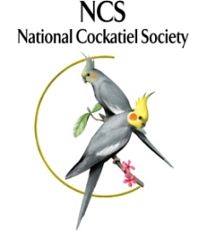 | NATIONAL COCKATIEL SOCIETY  CLUB AFFILIATION FORM

Club Information

Club Name:
Club Address:
City: | State: | Zip Code: | Phone:
Website: | E-Mail: |  | Send NCS  Journal Here: |  | Y |  | N

NCS Club Delegate – All NCS correspondence is sent to your NCS Club Delegate

Delegate Name:
Address (No P.O. Box):
City: | State: | Zip Code:
Phone (Day) | (Night) | Fax: none
E-Mail: |  | Send NCS Journal Here: |  | Y |  | N

NCS Affiliation

Show Date |  |  |  | Affiliation Level  (Check only one per show, enter amount on right) |  |  |  |  |  |  | Affiliation Amount
1. |  |  |  |  | A $100 |  |  | B $60 |  | C $20 | $
2. |  |  |  |  | A $100 |  |  | B $60 |  | C $20 | $
3. |  |  |  |  | A $100 |  |  | B $60 |  | C $20 | $
4. |  |  |  |  | A $100 |  |  | B $60 |  | C $20 | $
Class B:  Check One |  |  | 1st-3rd BIS &  1st-3rd BN Awards OR |  |  |  |  | BIS & BN 1st -10th Rosettes |  |  | n/a
Check Number:
Club Affiliation, Check One: |  |  |  |  | Internet $10 OR |  |  |  | Regular $30 |  | $
Total of Show, Rosette and Club Affiliation Amounts - Total Enclosed: |  |  |  |  |  |  |  |  |  |  | $
NCS Sponsor of Affiliation:

NATIONAL COCKATIEL SOCIETY

AFFILIATED CLUB SHOW INFORMATION

In order for an Exhibitor to receive points towards achieving Champion and Grand Champion status in the National Cockatiel Society, a Club must affiliate and use an NCS Judge.
Show Affiliation forms must be filled out completely and submitted to the Club Affiliations Chair, with proof of payment for the shows, 16 weeks (120 days) prior to the date of your show in order to receive the full show benefits package:
- Publication in the NCS Journal and on the NCS website so your club can advertise your show to other NCS Members
- Awards shipped to arrive for your show date
- This also allows ample time for Exhibitors to plan their show schedule for the year - remember people need to request time off to attend the shows and budget for travel.
We understand that opportunity may arise to put together a show in less than 16 weeks. Shows Affiliated less than 16 weeks, but no later than 6 weeks prior to the show, are permissible, as follows:
Show Affiliation forms submitted to the Club Affiliations Chair 8 weeks to 119 days prior to your show date, must include Show Affiliation forms that are filled out completely with proof of payment for the shows. These shows will receive a partial show benefits package:
- Publication on the NCS website
- Awards shipped to arrive for your show date
Shows requested with less than 6 weeks notice will be deemed "Short notice requests" and will need approval from the Board, but will not be eligible for the awards package. The Board will review any short notice requests and the Club Affiliations Chair will respond to the Club Delegate with the Board's decision.
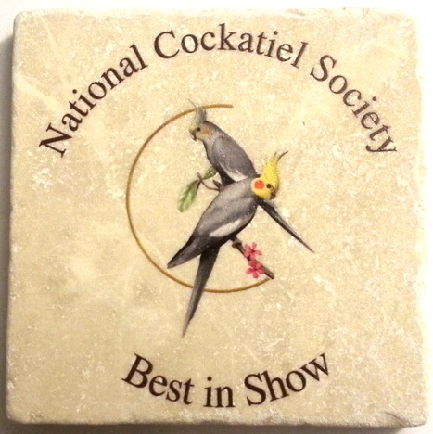
Please note the change in the 2016 Awards Package:
In lieu of Best in Show & Best Novice 1st place plaques, we will have a NEW award for Clubs to choose: 1st, 2nd & 3rd Best in Show and 1st, 2nd & 3rd Best Novice Tumbled Stone Coasters (4”x4”) with the National Cockatiel Society Logo and Place on the Advanced or Novice Bench.
- Class A Shows will receive 1st, 2nd & 3rd BIS and BN Tumbled Stone Coasters and a full set of BIS & BN 1st – 10th Rosettes.
- Class B Shows – Clubs may choose either the 1st, 2nd & 3rd BIS and BN Tumbled Stone Coasters OR the 1st – 10th BIS & BN Rosettes.

NATIONAL COCKATIEL SOCIETY

AFFILIATED CLUB SHOW INFORMATION

Show Information
Club Name:
Show Location:
Show Address :
City: | State: |  | Zip Code:
Show Date: | Class (Choose A, B or C) |  | NCS Judge:
Show Date: | Class (Choose A, B or C) |  | NCS Judge:
Show Date: | Class (Choose A, B or C) |  | NCS Judge:
Show Date: | Class (Choose A, B or C) |  | NCS Judge:

NCS Show Delegate - Awards will be shipped to your NCS Show Delegate
Check here, if same as Club Affiliation Delegate and leave blank below.
Delegate Name:
Address (No P.O. Box):
City: |  | State: |  | Zip Code:
Phone (Day) |  | (Night)
Fax: |  | E-Mail:
Mail this form along with copies of payment to: | NCS Club Affiliations  Carla Crowe  1342 Hildreth Pool Road  Bowie, TX 76320  Or email to: ncsclubscsc@gmail.com |  | Mail Payment to (Payable to NCS):  NCS Treasurer, Deb Dollar  PO Box 12058  Brooksville, FL 34601  Or paypal: ncscockatielsorg@gmail.com

